Web Proposal
Due February 12th 2025, 6pm (week 4)
(The proposal is part of your website mark)
One per Group Only
- List Group Names and Group Number

- One paragraph description of Proposed Website and Target Audience

- Site Map | 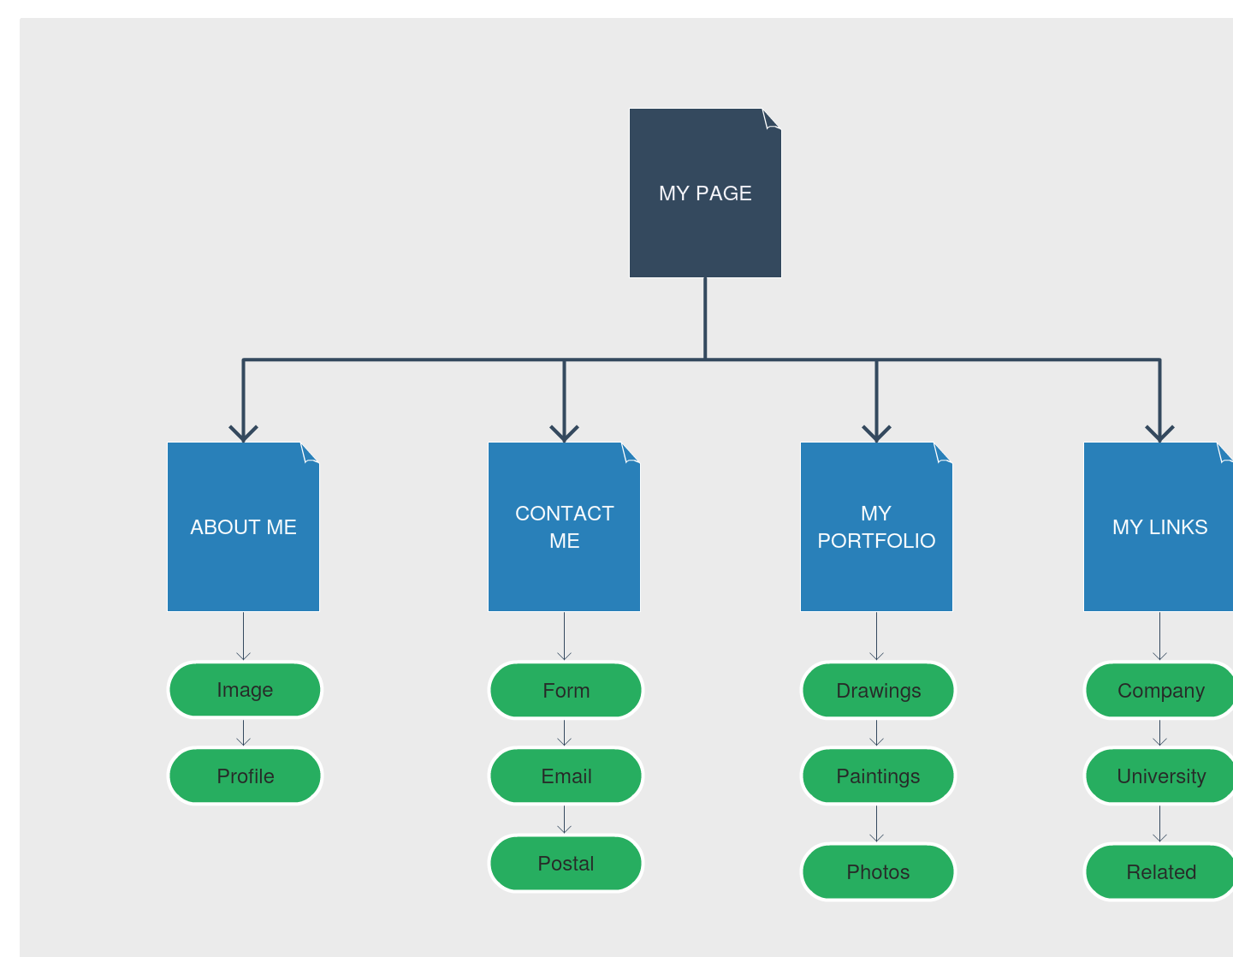
4.Wireframe  (one page only) | 